UNITED STATES
SECURITIES AND EXCHANGE COMMISSION
Washington, D.C. 20549
SCHEDULE 14A
Proxy Statement Pursuant to Section 14(a) of the
Securities Exchange Act of 1934
Filed by the Registrant ☒ Filed by a Party other than the Registrant ☐
Check the appropriate box:
☐ | Preliminary Proxy Statement
☐ | Confidential, for Use of the Commission Only (as permitted by Rule 14a-6(e)(2))
☐ | Definitive Proxy Statement
☒ | Definitive Additional Materials
☐ | Soliciting Material Pursuant to §240.14a-12
GOGO INC.
(Name of Registrant as Specified in Its Charter)
(Name of Person(s) Filing Proxy Statement, if other than the Registrant)
Payment of Filing Fee (Check the appropriate box):
☒ | No fee required
☐ | Fee paid previously with preliminary materials
☐ | Fee computed on table in exhibit required by Item 25(b) per Exchange Act Rules 14a-6(i)(1) and 0-11

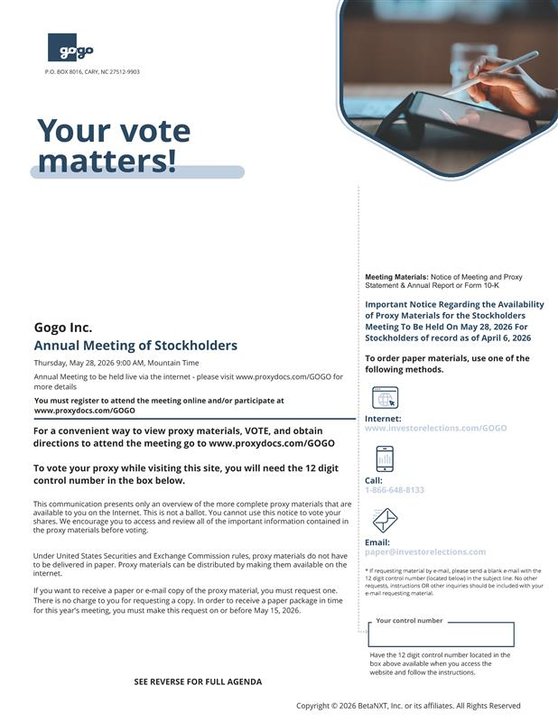
P.O. BOX 8016, CARY, NC 27512-9903 Gogo Inc. Annual Meeting of Stockholders Thursday, May 28, 2026 9:00 AM, Mountain Time Annual Meeting to be held live via the internet - please visit www.proxydocs.com/GOGO for more details You must register to attend the meeting online and/or participate at www.proxydocs.com/GOGO For a convenient way to view proxy materials, VOTE, and obtain directions to attend the meeting go to www.proxydocs.com/GOGO To vote your proxy while visiting this site, you will need the 12 digit control number in the box below. This communication presents only an overview of the more complete proxy materials that are available to you on the Internet. This is not a ballot. You cannot use this notice to vote your shares. We encourage you to access and review all of the important information contained in the proxy materials before voting. Under United States Securities and Exchange Commission rules, proxy materials do not have to be delivered in paper. Proxy materials can be distributed by making them available on the internet. If you want to receive a paper or e-mail copy of the proxy material, you must request one. There is no charge to you for requesting a copy. In order to receive a paper package in time for this year's meeting, you must make this request on or before May 15, 2026. SEE REVERSE FOR FULL AGENDA Meeting Materials: Notice of Meeting and Proxy Statement & Annual Report or Form 10-K Important Notice Regarding the Availability of Proxy Materials for the Stockholders Meeting To Be Held On May 28, 2026 For Stockholders of record as of April 6, 2026 To order paper materials, use one of the following methods. Internet: www.investorelections.com/GOGO Call: 1-866-648-8133 Email: paper@investorelections.com * If requesting material by e-mail, please send a blank e-mail with the 12 digit control number (located below) in the subject line. No other requests, instructions OR other inquiries should be included with your e-mail requesting material. Your control number Have the 12 digit control number located in the box above available when you access the website and follow the instructions. Copyright © 2026 BetaNXT, Inc. or its affiliates. All Rights Reserved Your vote matters

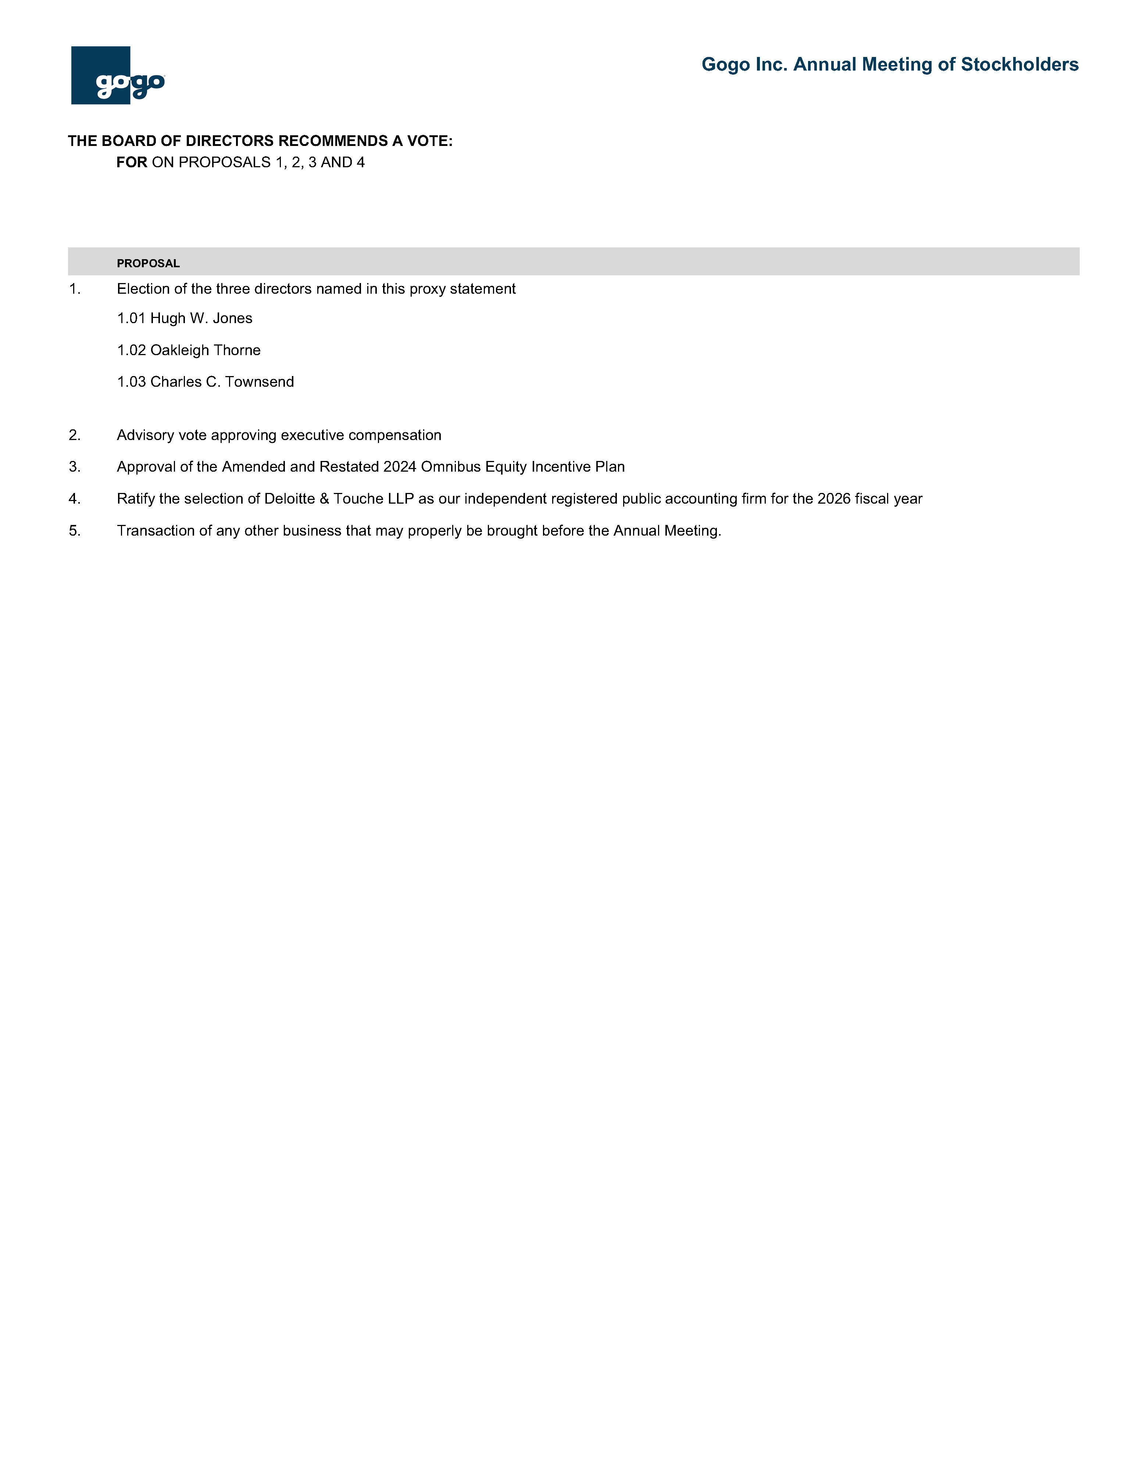
Gogo Inc. Annual Meeting of Stockholders THE BOARD OF DIRECTORS RECOMMENDS A VOTE: FOR ON PROPOSALS 1, 2, 3 AND 4 PROPOSAL 1. Election of the three directors named in this proxy statement 1.01 Hugh W. Jones 1.02 Oakleigh Thorne 1.03 Charles C. Townsend 2. Advisory vote approving executive compensation 3. Approval of the Amended and Restated 2024 Omnibus Equity Incentive Plan 4. Ratify the selection of Deloitte & Touche LLP as our independent registered public accounting firm for the 2026 fiscal year 5. Transaction of any other business that may properly be brought before the Annual Meeting

