UNITED STATES
SECURITIES AND EXCHANGE COMMISSION
Washington, D.C. 20549
SCHEDULE 14A
Proxy Statement Pursuant to Section 14(a) of the
Securities Exchange Act of 1934
Filed by the Registrant ☒ Filed by a Party other than the Registrant ☐
Check the appropriate box:
☐ | Preliminary Proxy Statement
☐ | Confidential, for Use of the Commission Only (as permitted by Rule 14a-6(e)(2))
☐ | Definitive Proxy Statement
☒ | Definitive Additional Materials
☐ | Soliciting Material Pursuant to §240.14a-12
GOGO INC.
(Name of Registrant as Specified in Its Charter)
(Name of Person(s) Filing Proxy Statement, if other than the Registrant)
Payment of Filing Fee (Check the appropriate box):
☒ | No fee required
☐ | Fee paid previously with preliminary materials
☐ | Fee computed on table in exhibit required by Item 25(b) per Exchange Act Rules 14a-6(i)(1) and 0-11

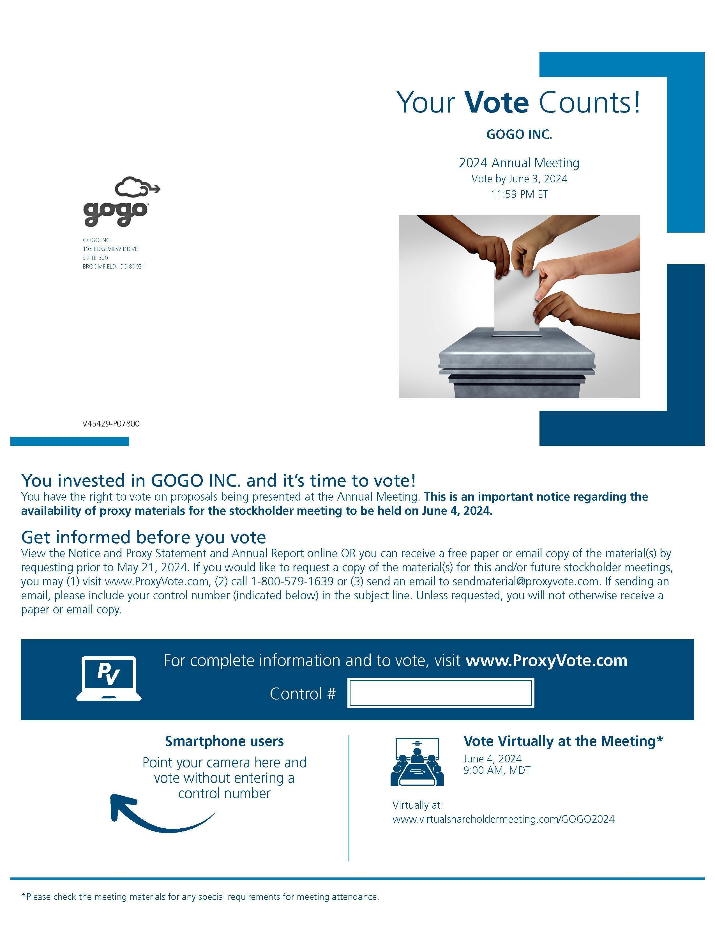Your Vote Counts! GOGO INC. 2024 Annual Meeting Vote by June 3, 2024 11:59 PM ET GOGO INC. 105 EDGEVIEW DRIVE SUITE 300 BROOMFIELD, CO 80021 V45429-P07800 You invested in GOGO INC. and it’s time to vote! You have the right to vote on proposals being presented at the Annual Meeting. This is an important notice regarding the availability of proxy materials for the stockholder meeting to be held on June 4, 2024. Get informed before you vote View the Notice and Proxy Statement and Annual Report online OR you can receive a free paper or email copy of the material(s) by requesting prior to May 21, 2024. If you would like to request a copy of the material(s) for this and/or future stockholder meetings, you may (1) visit www.ProxyVote.com, (2) call 1-800-579-1639 or (3) send an email to sendmaterial@proxyvote.com. If sending an email, please include your control number (indicated below) in the subject line. Unless requested, you will not otherwise receive a paper or email copy. For complete information and to vote, visit www.ProxyVote.com Control # Smartphone users Point your camera here and vote without entering a control number Vote Virtually at the Meeting* June 4, 2024 9:00 AM, MDT Virtually at: www.virtualshareholdermeeting.com/GOGO2024 *Please check the meeting materials for any special requirements for meeting attendance.

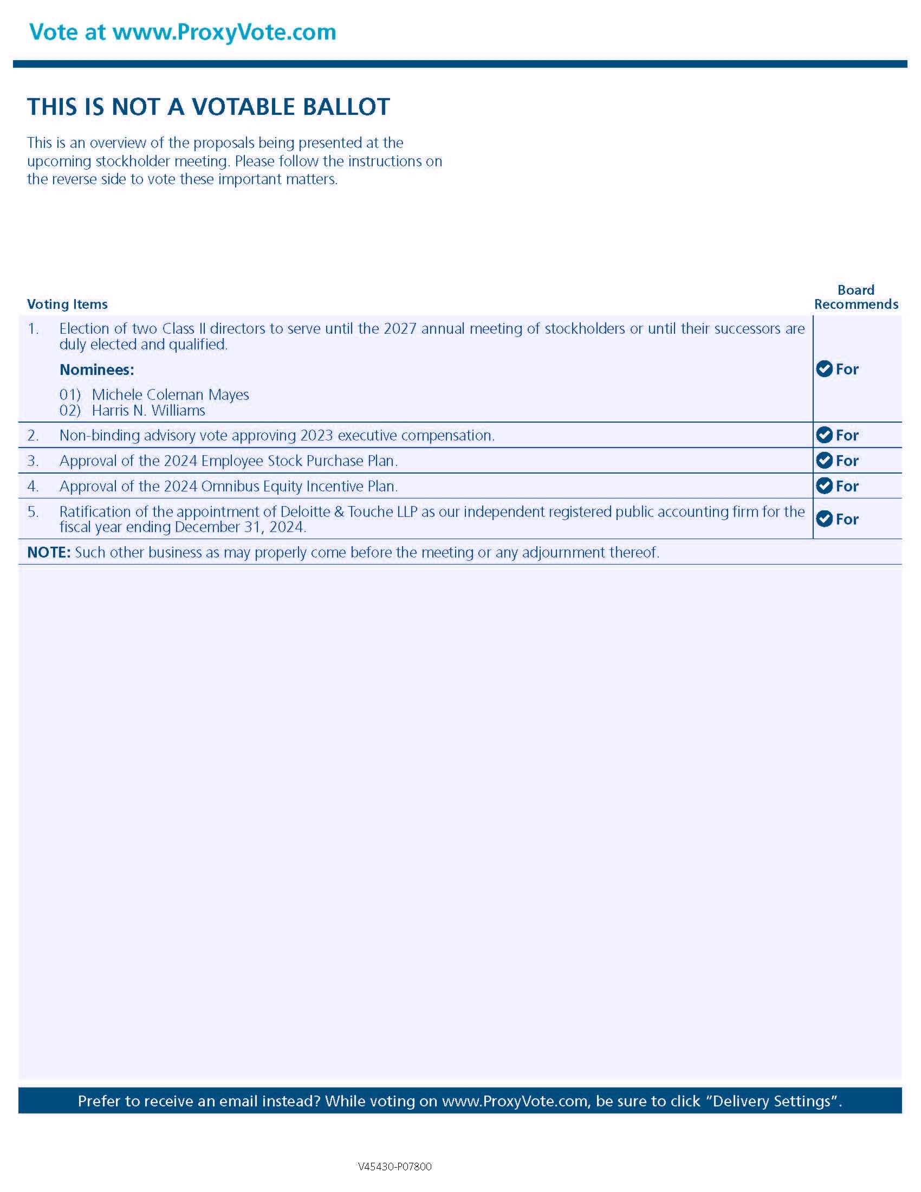Vote at www.ProxyVote.com THIS IS NOT A VOTABLE BALLOT This is an overview of the proposals being presented at the upcoming stockholder meeting. Please follow the instructions on the reverse side to vote these important matters. Board Recommends Voting Items 1. Election of two Class II directors to serve until the 2027 annual meeting of stockholders or until their successors are duly elected and qualified. For Nominees: 01) Michele Coleman Mayes 02) Harris N. Williams 2. Non-binding advisory vote approving 2023 executive compensation. For 3. Approval of the 2024 Employee Stock Purchase Plan. For 4. Approval of the 2024 Omnibus Equity Incentive Plan. For 5. Ratification of the appointment of Deloitte & Touche LLP as our independent registered public accounting firm for the fiscal year ending December 31, 2024. For NOTE: Such other business as may properly come before the meeting or any adjournment thereof. Prefer to receive an email instead? While voting on www.ProxyVote.com, be sure to click “Delivery Settings”. V45430-P07800

